PRACTICAL: 7.1

**AIM:** Implement Inter VLAN Routing Configuration

# THEORY:

Inter-VLAN routing can be defined as a way to forward traffic between different VLAN by implementing a router in the network. As we learnt previously, VLANs logically segment the switch into different subnets, when a router is connected to the switch, an administrator can configure the router to forward the traffic between the various VLANs configured on the switch. The user nodes in the VLANs forwards traffic to the router which then forwards the traffic to the destination network regardless of the VLAN configured on the switch.

# TOPOLOGY:

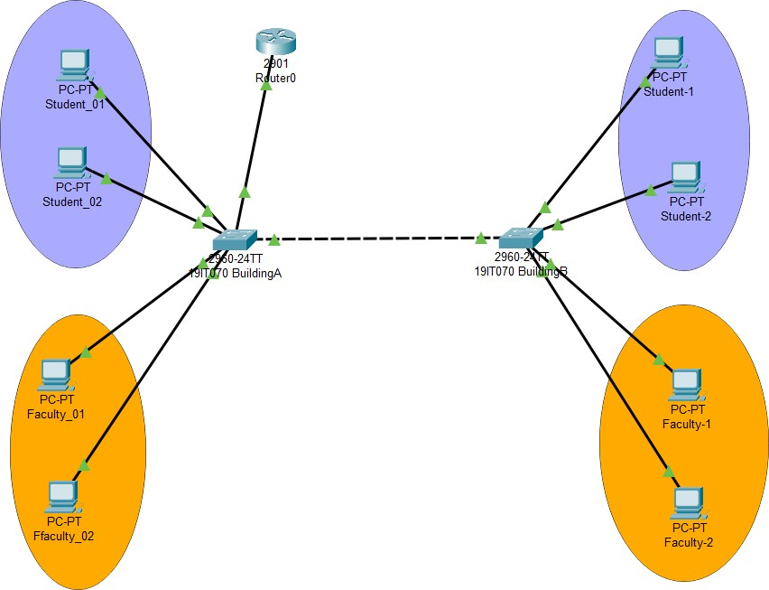

**Commands:**

1. First, we have to make separate VLAN for both switches and we have to made truncate between two switches using truncate

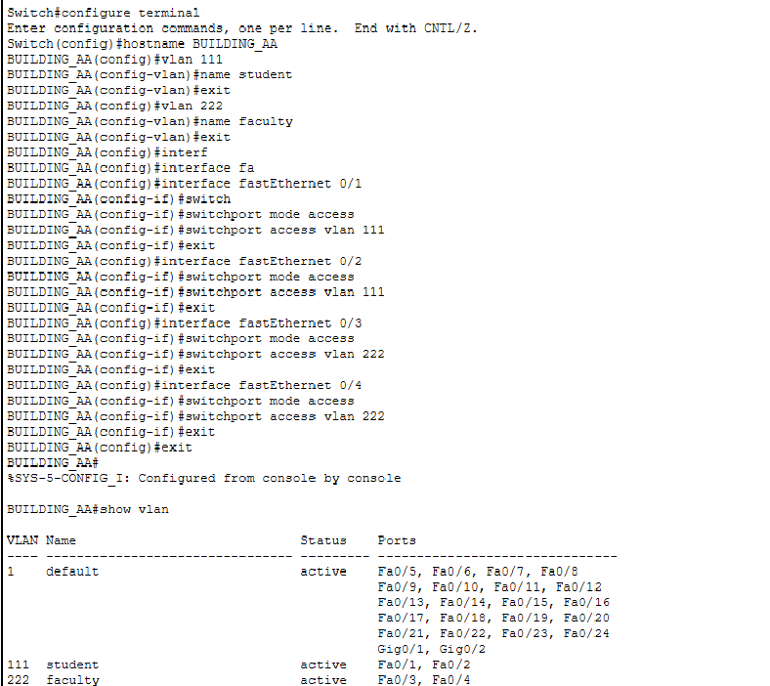

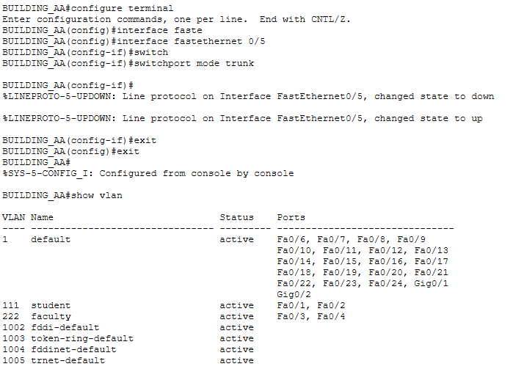

Same procedures with BUILDING__BB switch

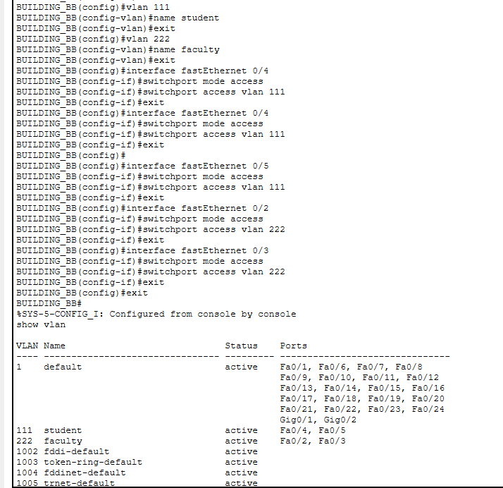

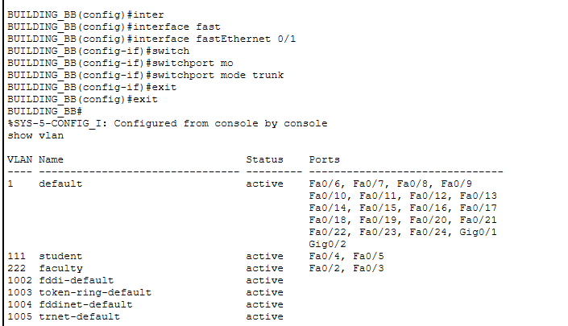

1. Now we will have to use Router to make Inter VLAN between this two VLANs

# Command:

**Screenshot :**

## enable

**configure terminal**

## interface gigabitEthernet 0/0.1 no shutdown

**encapsulation dot1Q 111**

## ip address 10.0.1.5 255.255.255.0 exit

**interface gigabitEthernet 0/0.2 no shutdown**

## encapsulation dot1Q 222

**ip address 10.0.2.5 255.255.255.0 exit**

## interface gigabitEthernet 0/0 no shutdown

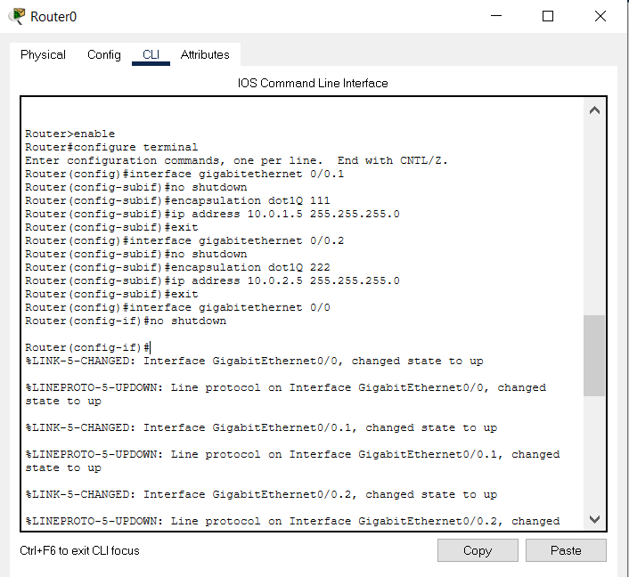

1. Now we have to provide specific ip address as Default gateway to specific PC.
2. Now we have to trunk the switch port that is connecter to the router

# Screenshot :

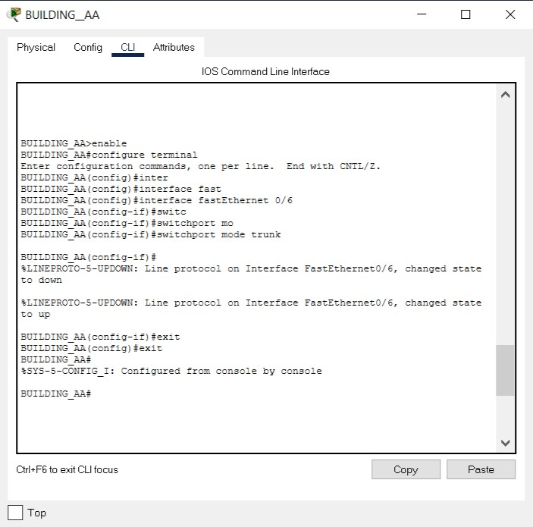

**OUPUTS:**



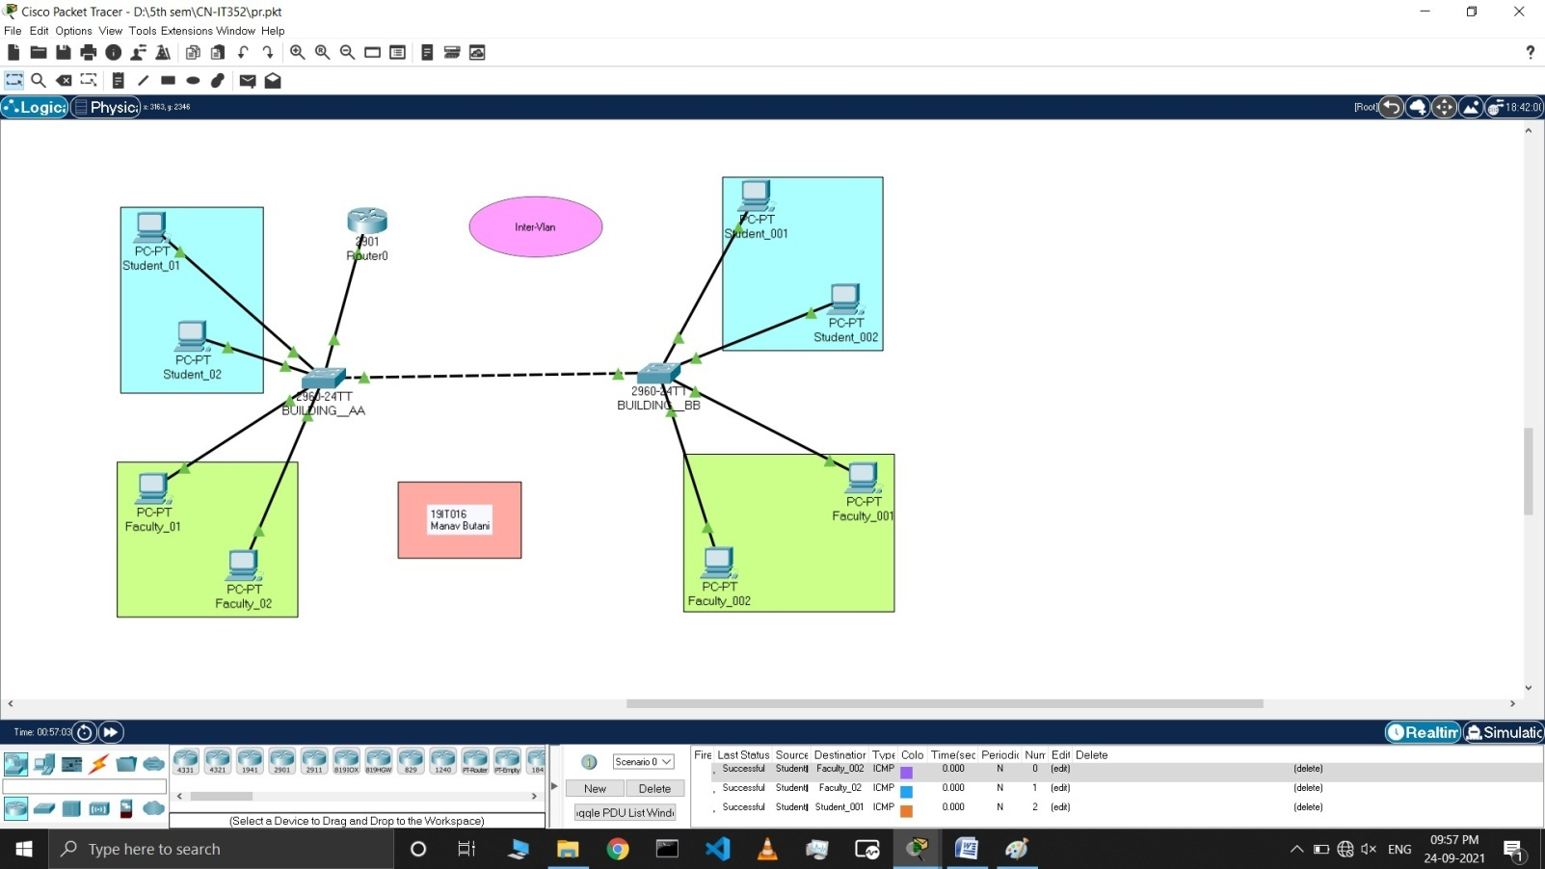

# LATEST APPLICATIONS:

* + performance –The network traffic is full of broadcast and multicast. VLAN reduces the need to
  + send such traffic to unnecessary destinations.
  + formation of virtual groups – As there are different departments in every organization namely sales, finance etc., VLANs can be very useful in order to group the devices logically according to their departments.
  + security – In the same network, sensitive data can be broadcast which can be accessed by the outsider but by creating VLAN, we can control broadcast domains, set up firewalls, restrict access. Also, VLANs can be used to inform the network manager of an intrusion. Hence, VLANs greatly enhance network security.

# LEARNING OUTCOME:

In this practical we learned about what is Inter VLAN and in real life how we can use Inter VLAN Using Router and make specific VLAN group.